MOTECH Suite Behavior Change Communication

Functional Specification

October 22, 2012

# Overview

MST applications have the potential to increase knowledge about health, encourage providers to support positive health behaviors, and reduce vulnerable population’s barriers to access crucial health services. MST supports video, image and audio health messages and individual behavior communication strategies.

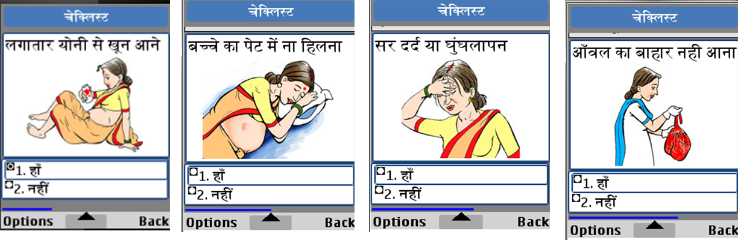

Figure 1: Multimedia in MST

MST supports customizable behavior change interventions based on a patient’s personal characteristics, performance over time, and the time of the intervention.

# Use Cases

## BCC on Handset Application

A health worker using the handset application can select a form to run on one of the cases she ha previously registered. A single form can serve many purposes including data capture, screening algorithms, referrals, and behavior change. The behavior change messages delivered can include text that appears on the phone, optional pre-recorded audio files that can be played from the phone to the client, and images or videos that can be shown to the video.

## BCC by IVR or SMS

MST can also deliver information via text message or pre-recorded audio files delivered over IVR. The client can be called on her phone or she can initiate the call at a time of her choosing. A pin code can be required to verify the identity of the client.

# MOTECH Suite Modules / Systems

Which behavior change messages are delivered can be vary based on timing (e.g., if a pregnant women is in the first, second, or third trimester) and information collected for that case (e.g.., the age of the woman or information about previous deliveries). See the brief of MST Forms to learn more.

# Issues/Questions